Instructions for Emailing Governor Newsom
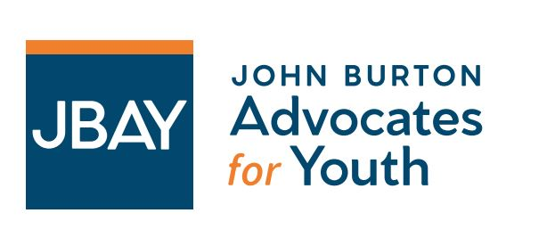
Below is a template to email Governor Newsom in support of $1 billion in funding for HHAP Round 7 and the authorization of HHAP Round 8. When emailing, please be sure to CC brandon@jbay.org so we can track who submitted emails.
Content of Email
TO: leg.unit@gov.ca.gov
CC: brandon@jbay.org;
SUBJECT: SUPPORT: Protect the 39% Reduction in Youth Homelessness by Providing $1 Billion for Round 7 of the Homeless Housing, Assistance and Prevention (HHAP) program and Authorizing Round 8
EMAIL BODY:
Dear Governor Newsom,
My name is [Your Name], and I'm with [Your Organization]. Today, I join the Youth Homelessness Minimum Funding Guarantee coalition, a statewide coalition of more than 75 youth-serving homelessness, healthcare, and community organizations and 36 individuals working to preserve the progress California made in reducing youth homelessness by 39% from 2020 to 2025. I am writing to respectfully urge you to revise your funding decisions in the 2026-27 budget and ask that you support a total of $1 billion for the Homeless Housing, Assistance and Prevention (HHAP) program in the 2026–27 state budget and authorize Round 8 of HHAP in the final budget.
[Personalize your message here. Is your program funded by HHAP? What services do you provide? Can you share a story of a youth who benefited from HHAP?]
California has experienced unprecedented progress in reducing youth homelessness. Between 2020 and 2025, HHAP reduced youth homelessness in California by 39% overall, and between 2019-2024, reduced unsheltered youth homelessness by 42%. It is crucial that the momentum behind ending youth homelessness is maintained through investments that match the last four rounds of HHAP funding. The absence of new HHAP funding in the May Revise places this progress at risk at a time when communities across the state continue to face immense housing instability and growing need.
I appreciate your administration's longstanding commitment to addressing homelessness and supporting the most vulnerable youth in California. We respectfully ask that you continue your leadership on this issue and help build a lasting legacy of advancing real, long-term solutions to homelessness by investing $1 billion in HHAP Round 7 and authorizing HHAP Round 8.
Thank you for your consideration and leadership.
Sincerely,
[Your Name]
[Your Organization]

