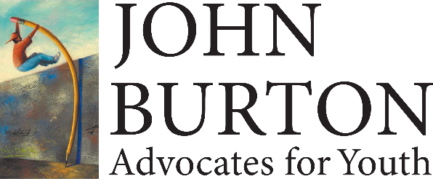

***2017-18 Burton Book Fund Campus Representative Agreement***

***Please send agreements to:*** [martha@jbaforyouth.org](mailto:martha@jbaforyouth.org)

1. ***Campus Information***

Campus Name: ______________________________________________

Campus Rep Office Address: ______________________________________________

______________________________________________

______________________________________________

1. ***Campus Foster Youth Representative Information***

Name: _________________________________________________

Title: _________________________________________________

Email: _________________________________________________

Phone: _________________________________________________

1. ***Agreement***

By signing this agreement, I hold myself and all program staff implementing the Burton Book Fund program to the following requirements:

1. I will ensure that only approved students make textbook charges to the Burton Book Fund.
2. I will ensure that all students applying for the Burton Book Fund meet the eligibility requirements and have a major financial need.
3. I and my staff will work with students to utilize all other forms of textbook support before utilizing the Burton Book Fund program.
4. I and my staff will make sure to go over the rules of the program with students as they submit their applications.
5. I will not share the Burton Book Fund student application and campus code with any non-staff members.
6. I will inform all approved students that textbook purchases can only be made from: **August 7th, 2017- April 15th, 2018.**
7. I will inform all students that the grants they receive are intended to be used by for the 2017-18 academic year, that grants are not transferable, and that any unused funds cannot be used for a later semester/quarter.

1. I will maintain a list of all students who have been approved for the Burton Book Fund. This list will include the following information:
2. Student Name
3. Student ID number
4. Grant amount
5. I will send this list to the campus bookstore and inform the bookstore regularly of what students have been authorized to make charges to the Burton Book Fund account.
6. I will make sure that all approved students know that they are only allowed to use their grants to only purchase textbooks. I will inform them that they will be responsible for any non-textbook charges or overcharges they make to the Burton Book Fund account.
7. I will be in contact with the bookstore to ensure that students do not exceed their grant amounts and that they do not make unauthorized charges to the Burton Book Fund account.
8. I agree to share student retention data with John Burton Advocates for Youth in order track the success of the program.

Student award amounts for the 2017-18 Burton Book Fund are:

* **Students enrolled in 6-8 units will receive $100 in textbook fund support.**
* **Students enrolled in 9-11 units will receive $175 in textbook support.**
* **Students enrolled in 12 or more units will receive $250 in textbook support.**

1. ***Signature***

I, the undersigned, agree to the above conditions. I understand that if I do not abide by the requirements listed above, that my campus can become ineligible to participate in the Burton Book Fund in future years. I and any other active foster care representatives working with the Burton Book Fund on my campus will work to ensure that the rules and requirements for the Burton Book Fund are followed to the best of our ability.

Campus Representative Signature: _________________________________________

Print Name and Title: ____________________________________________________

Date: ________________________________________________________________

For any questions, please contact:

**Martha Joseph**

**Operations Manager**

**415-348-0011   
martha@jbaforyouth.org**